Regrarians Platform Checklist

Client:
1. CLIMATE
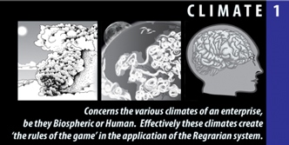
Decision Makers
Primary (veto power)
Secondary
Tertiary
Disabilities
Allergies
Resource Base
People & Organizations of Influence
City Council
Planning Commission
Physical Resources
Land Base & Tenures
Sources of Money
Money Flow, Procurement, Investments, Reliability
Quality of Life
What gets you out of bed?
What makes a good life?
Forms of Production  What must be created or achieved in order to attain each Quality of Life statement? | T
Future Resource Base
How you have to behave?
The Future Landscape?
The Future Community?
The Future Infrastructure?
On this farm - natural inbuilt infrastructure to advance?
Intergenerational Succession
Strategy
Recipients
Ecoliteracy
Biospheric Factors (WRCC)
Solar Radiation/Insolation
Sun Hours/year
Cloud Days/year
Insolation - MJ/m²/year or kWh/m²/day
Temperature
July–avg. minimum
July–avg. maximum
December–avg. minimum
December–avg. maximum
Highest Recorded–when?
Lowest Recorded–when?
USDA Hardiness Zone
Sunset Zone
Growing Degree Days (GDD)
+0°C
+10°C
+15°C
Chilling Hours/year
Evapotranspiration/year
Precipitation (Max Events)
CIMIS Zone & Station
Reference ET_{o}
Rain Days/year
Rainfall–long term avg.
Rainfall–highest daily
Rainfall–highest annual
Rainfall–lowest annual
Snow–long term avg.
Rainfall–highest daily
Snow–highest annual
Snow–lowest annual
Dew
Fog
Seasonality
Variability
Max. Days of Drought
Humidity
Highest month
Lowest month
Months humid/not humid
Frost
Frost Days/year
Earliest Recorded
Latest Recorded
Wind
Prevailing Direction
Strongest Recorded
Hazard
Microclimates (Locations & Description)
MC #1
MC #2
MC #3
2. GEOGRAPHY
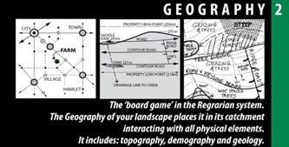
Longitude/Latitude
UTM Reference | Zone:  Latitude Band:  West Longitude:  Central Meridian Longitude:  East Longitude:
Google Base Map?
APN or Parcel Number
Address
Acreage
Population Centers (Name, Persons, Demography, Psychography)
0-10 Miles
11-25 Miles
26-50 Miles
51-100 Miles
101+ Miles (remote locations)
Geology
Bedrock
Surface
Landscape Components
List all
Maximum Elevation
Minimum Elevation
Site Regulations
Statutory Factors
Zoning/Planning Layers
Easements
Setbacks
Other Regulations
Jurisdictions
Wildlife Protection
Community Dynamics
Neighbors
Noises, Odors
Views
Utilities
3. WATER
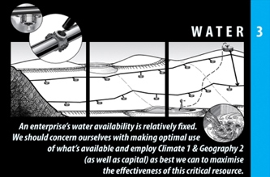
Access Rights
List available (+Costs/qty)
Groundwater
Names, elevation, quantities, quality, proposed
Streamflow
Names, elevations, quantities, quality, proposed
Dams & Ponds
Names, elevations, quantities, quality, proposed
Tanks & Cisterns
Names, elevations, quantities, proposed
Irrigation
Areas, rates, methods, proposed
Treatment
Names, types, volumes, proposed
Inundation
Locations
4. ACCESS
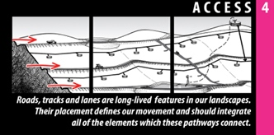
External Roads
Names, covering, width, capacity
Internal Roads
Names, covering, width, capacity, proposed
Utilities
Telephony (fixed, cellular, internet)
Propane/LPG
Electricity
Sewer
5. FORESTRY
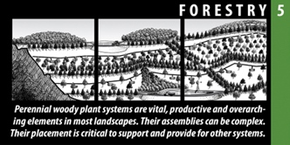
Existing Resources
Forest Types
Integration Potential
Orchards
Names, area, species, proposed
Tree Crops
Names, area, species, proposed
Production Forestry
Names, area, species, proposed
Revegetation
Names, areas, species, complexes, proposed
Field Crops
Names, area, species, proposed
Shelterbelts
Names, area, species, proposed
Wildlife
Species
Problem Species/Issues
Plants, animals, microbes, fungi
6. BUILDINGS
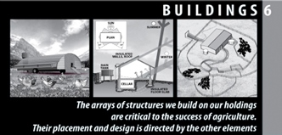
Dwellings
Names, elevation, roof area, occupants, conditions
Outbuildings
Names, elevation, roof area, use, conditions
Portable Structures
Names, types, conditions
Storages
Names, types, conditions
7. FENCING
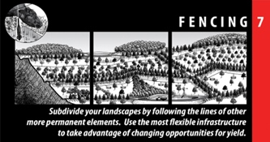
Permanent
Names, types, lengths, conditions
Semi-Permanent
Names, types, lengths, conditions
Temporary
Names, types, lengths, conditions
Living
Names, species, lengths, conditions
Yards
Names, types, lengths, conditions
8. SOILS
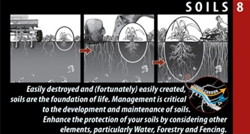
Agronomic
Soil types, areas, tests
Geotechnic
Areas, tests
Residues/Toxins
Areas, tests
Artificial Treatments
Names, types, areas, history
Biological Treatments
Names, types, areas, history
Livestock Treatments
Names, types, areas, history
9. ECONOMY
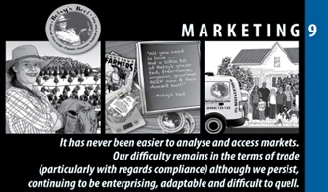
Enterprises
List all
Corporate
Financial Planning
Strategy
Budget
Certifications
List all
Insurances
List all
Governance
Accountant
Lawyer
Consultant(s)
Marketing
What problem are you solving?
Strategy
Narrative
Analysis
Industry players
Collaborators
Outreach
Web/Social Media Sites
List all
Processing
Description
Compliance
Logistics
Description
Payments for Ecosystem Services
Strategy
List all
10. ENERGY
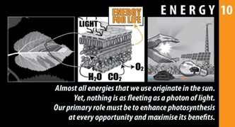
Capture & Storage
List all (inc. rating, capacity & condition)
Future Strategy
Machine Implements
List all (inc. model, capacity, condition and last use
ADDITIONAL NOTES

